Login to AWS dashboard, and go to us-west-1 region

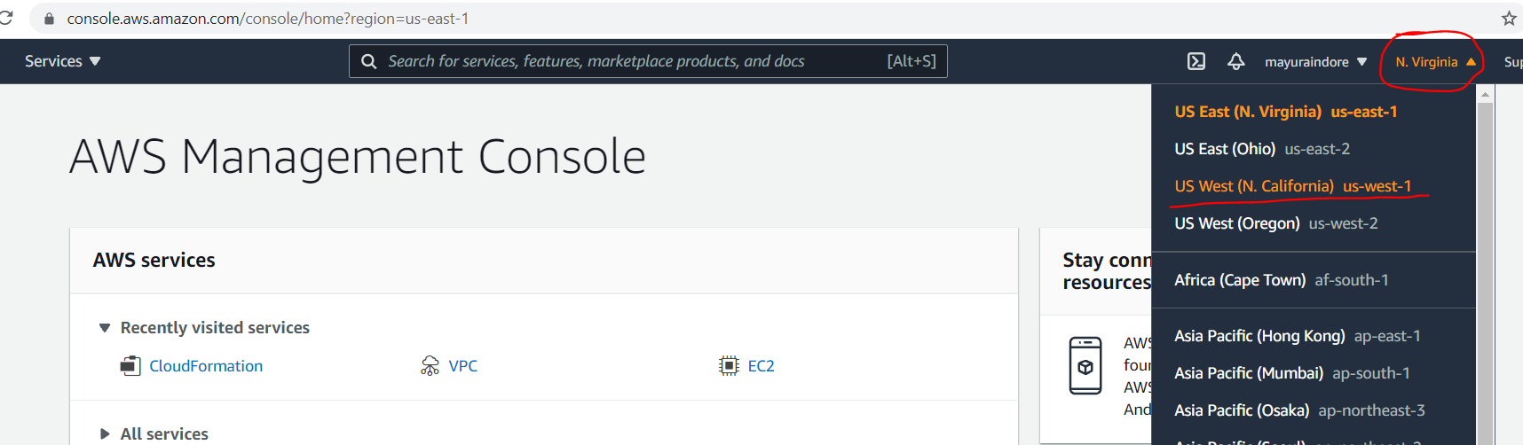

Type **ec2** in search bar and click on **EC2** service

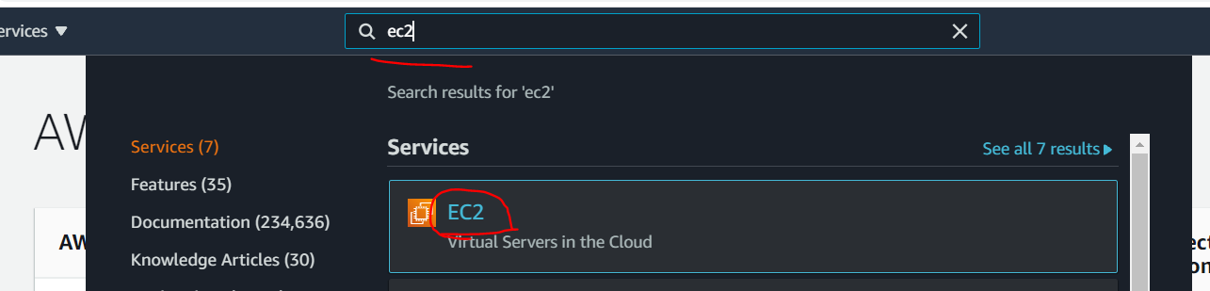

Click on **Instances**

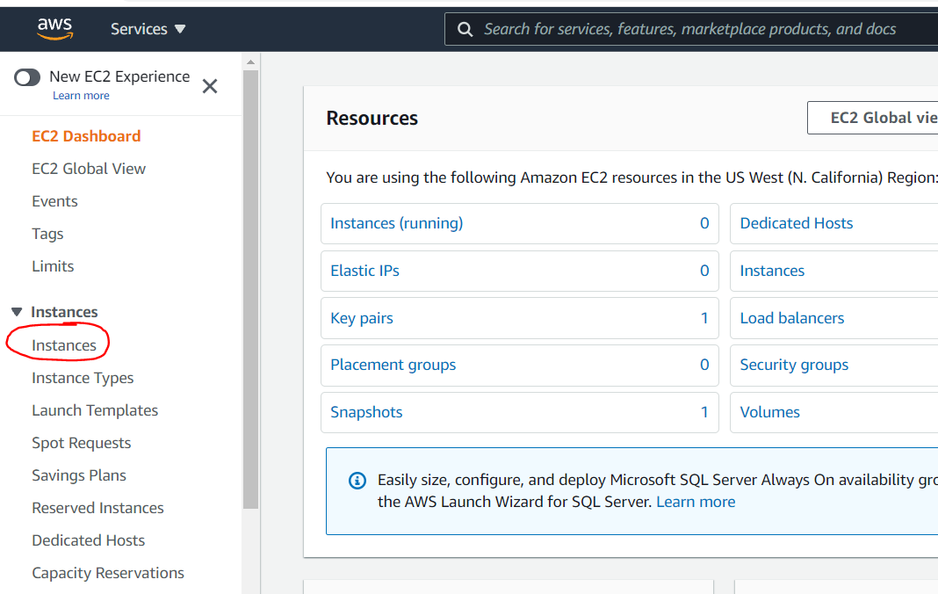

Click on **Launch Instance**

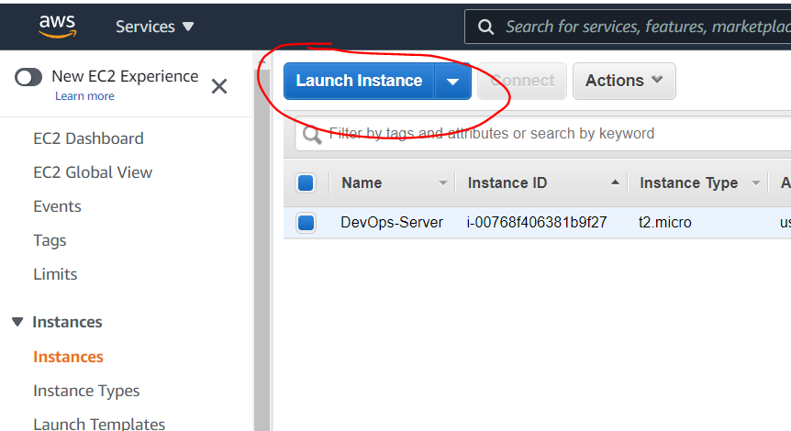

Please note down steps to spin EC2 instances at top.

Click on **Free tier only** checkbox, and then select **Amazon Linux 2 AMI** only.

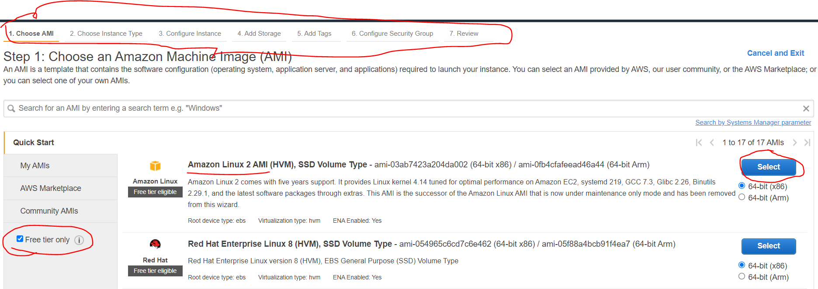

Be sure you have selected **Free tier eligible** instance type only which is **t2.micro** by default selected.

Click on **Configure Instance Details**

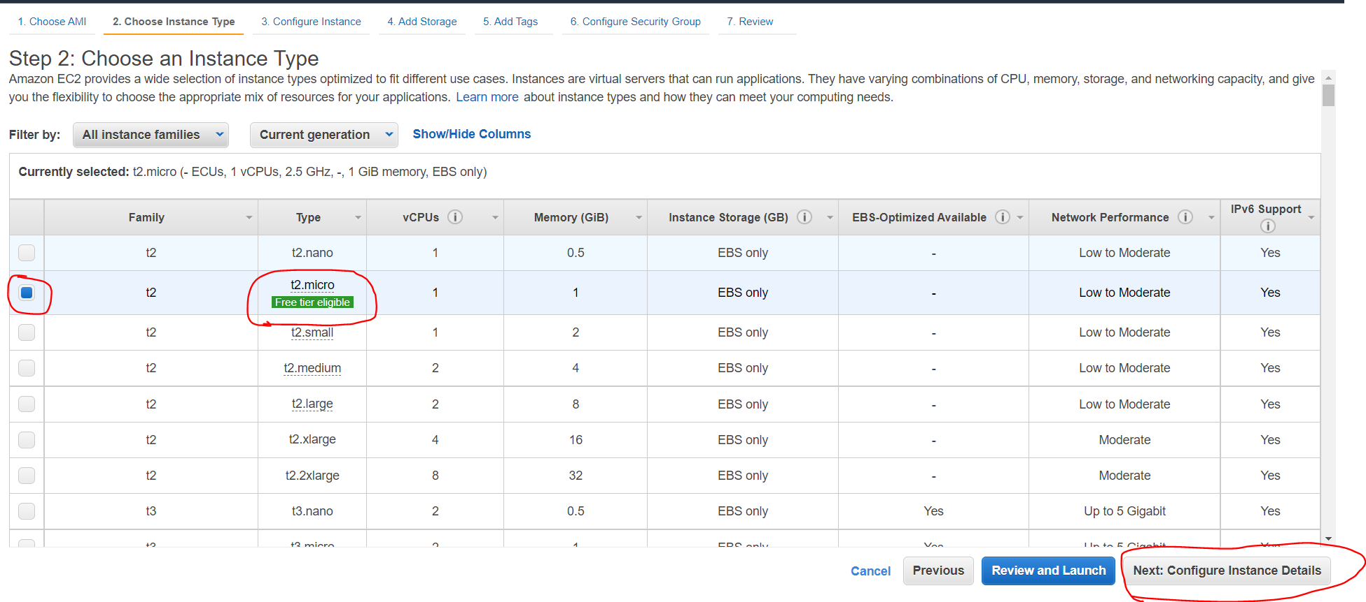

Select **DEVOPS** in Network option.

Select **DEVSUB** in Subnet option.

Scroll down, go to at the end of the page.

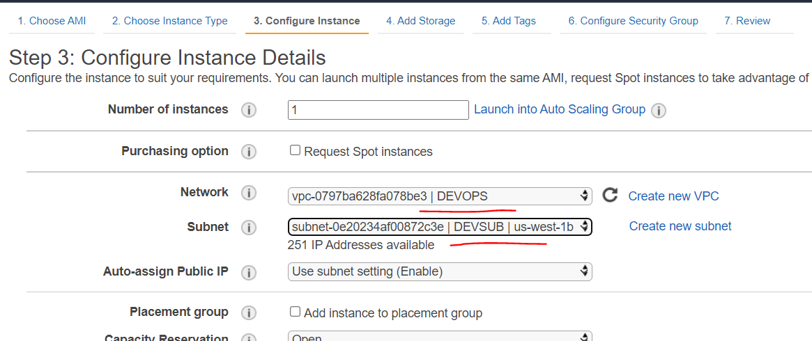

At the end of the page User data section available. Copy-Paste our userdata script, which will enable password login, and create admin user with password as admin. Because of this script you can login on server without key.

Click on **Add Storage**

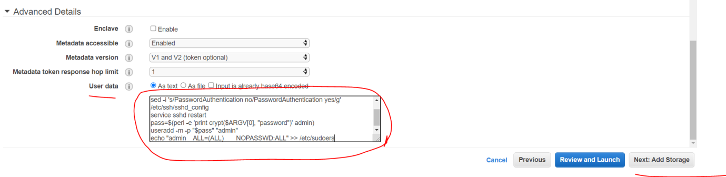

Click on **Next**

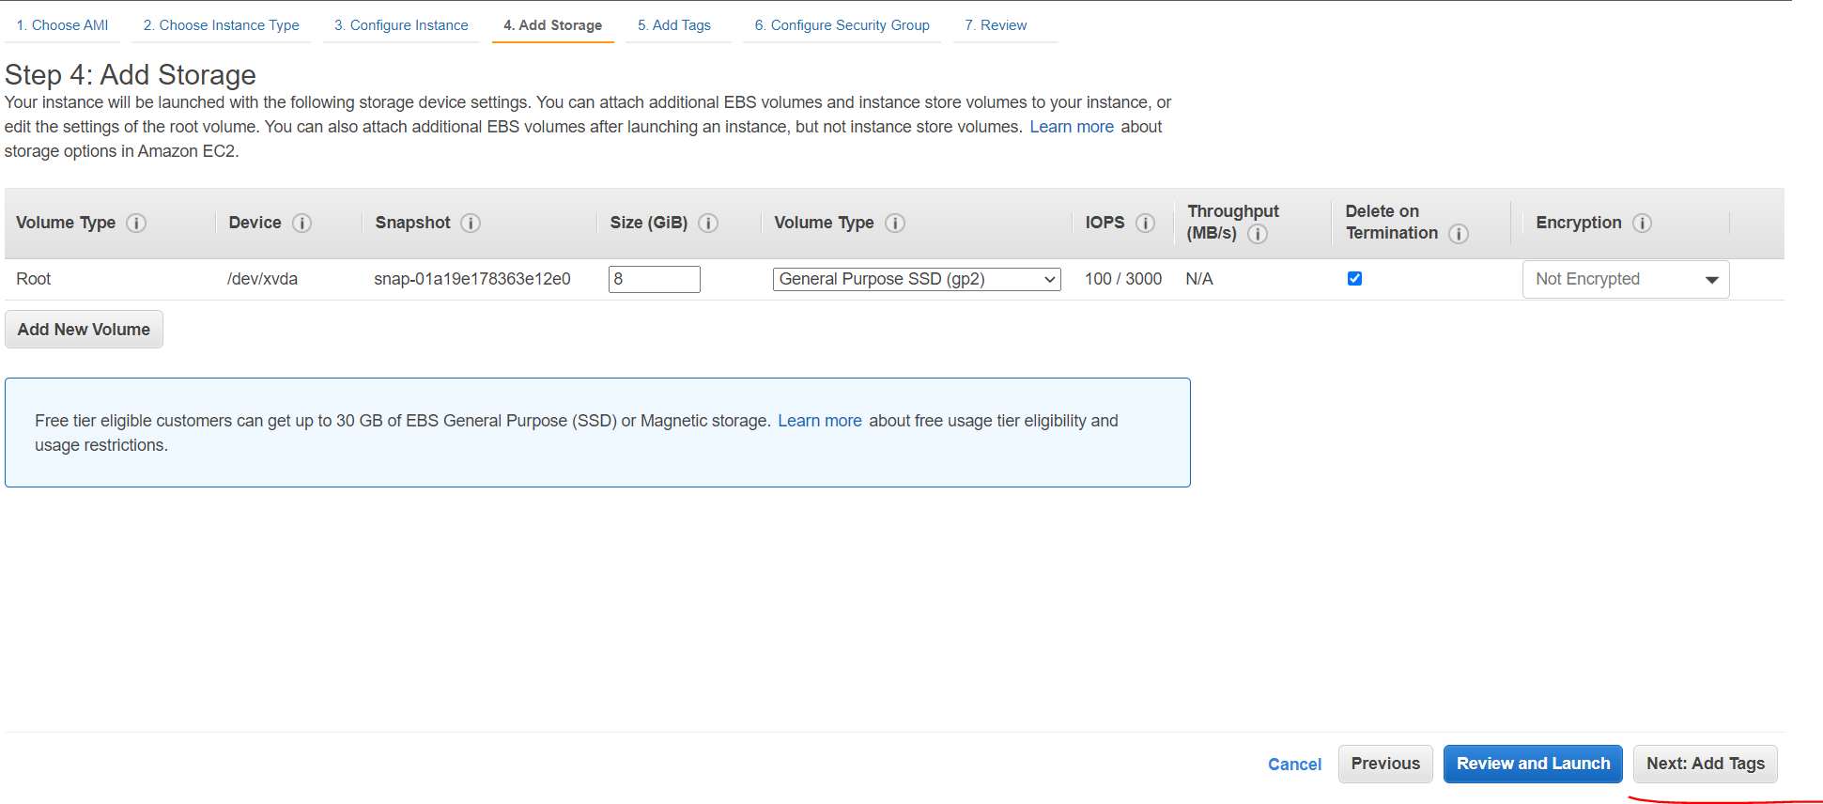

Click on **Next**

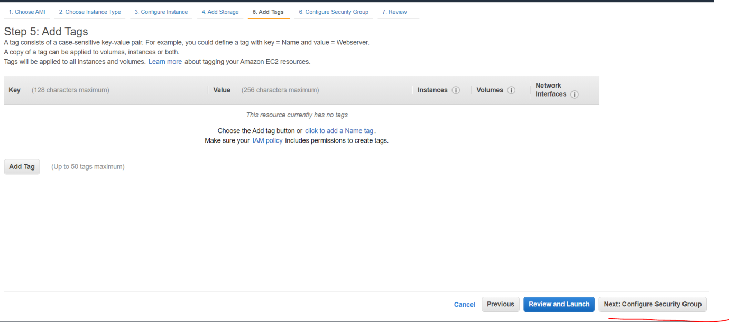

Select **Existing security group** option

Select **DEVSG** security group

Click on **Review and Launch**

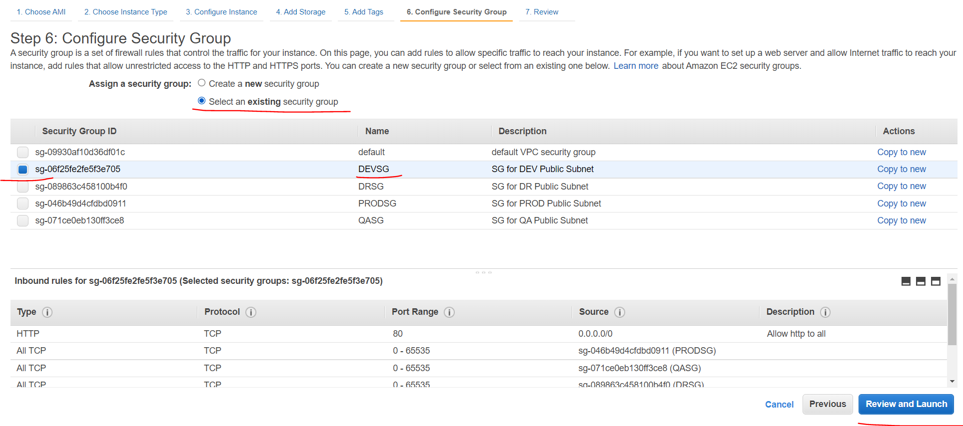

Click on **Launch**

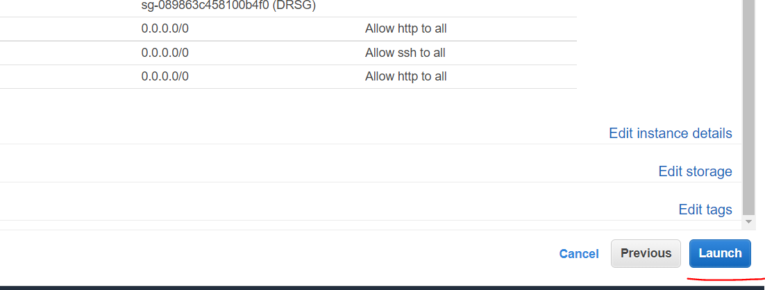

It will ask for KEY, if you have already any key exist, select that one from dropdown menu,

Click on **acknowledge** checkbox.

Click on **Launch Instances**

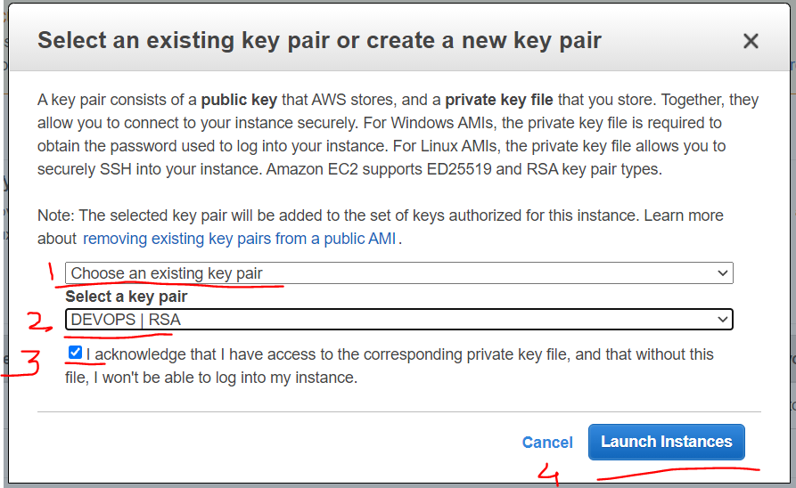

If you don’t have any existing key, then select **Create a new key pair** option.

Provide key name as **DEVOPS**

Click on **Download** button to download key

Click on **Launch Instances**

